Derek Renfro

Ryan Conyac

KWIC Web-based Search Engine

1. Requirement Specifications

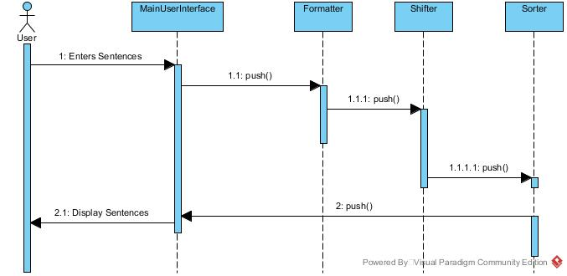

For this requirements we found three items that were not precisely clear on the specification. The first was that the number of times the words are shifted, we assumed that since this would be used for a search engine and it would need to find all the words in a document. So we extended this to include that all of the words should show up as the first word of a shifted sentence once. The next item that we found was Unicode characters were not specified so we had them taken in as input but we are not sorting them as the sorting can depend on the language that is being used. The last item we found was the interface, we assumed that this would need a simple interface for the strings to be entered into and for them to be read out of, we also added a clear function for ease of use.

2. Architecture specification

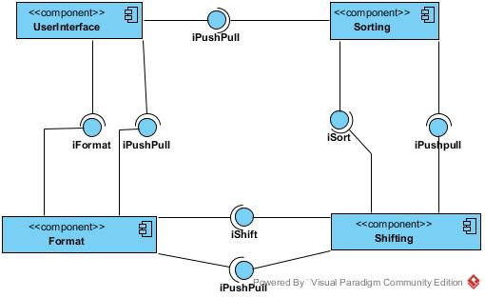

In this design we have broken the application into four components. The UserInterface component contains the parts that the user will see and interact with. This includes the text boxes and buttons, where the data will be sent to the Format component. The next component is the Format component, with this component being called by the UserInterface it will receive the strings the user entered and format them as the design requirement specified then pass the formatted strings to the Shifting component. This Shifting component where the strings are shifted as the requirements stated processes all of the received strings. These strings are passed to the Sorting component from the Shifting component. Where the strings are sorted into the format as required from the customer. Lastly the sorting component will then pass the strings to the UserInterface component so that the user can see the shifted and sorted strings for the sentences they had used. The connectors that are used in this design are pipes as they allow for more advanced usage of resources as once the component is done processing the strings it is able to be removed from memory. Another is that it allows for more easily to update the software as the pipe does not need to be changed only the receiving end will need to be updated. One of the disadvantages about this type of set up is the usage of resources, as many threads are created and have to be handled by the processor until they are done running. This can take time away from other system processes that are running or waiting for resources to become available. A constraint for this system also includes the requirement of Java Runtime Environment 8.x family, as the resources and language are new to the java family and do not function on lower level environments.

3. Design Specification

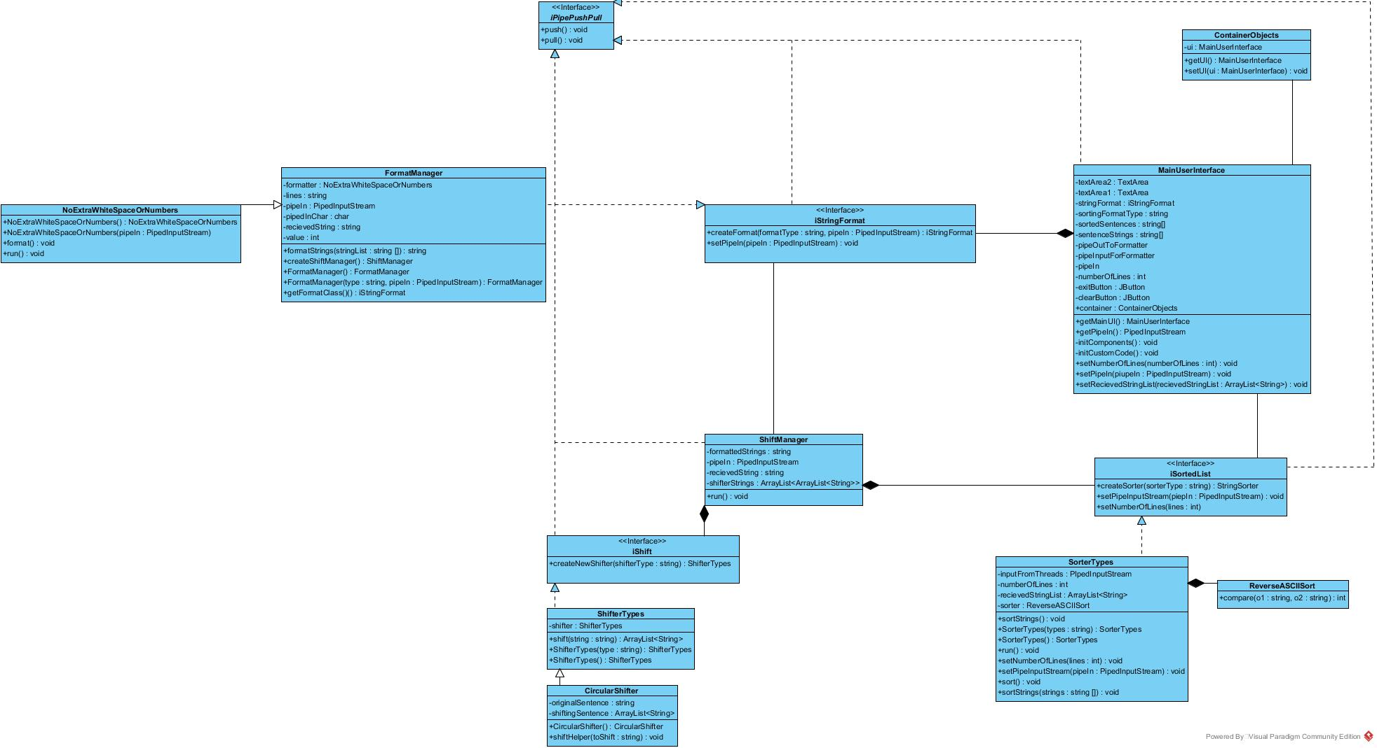

4. User Manual

Once the user launches the application they will see two boxes and two buttons below. The top box is for inputting the strings into the program. These can be broken by new lines or they can be all together as one long unit. Below that is the output box that the sorted and shifted sentences will be output to. Below that is the submit, clear. The submit button once pressed will process the sentences and display them in the output box. The clear button will clear both of the text boxes.

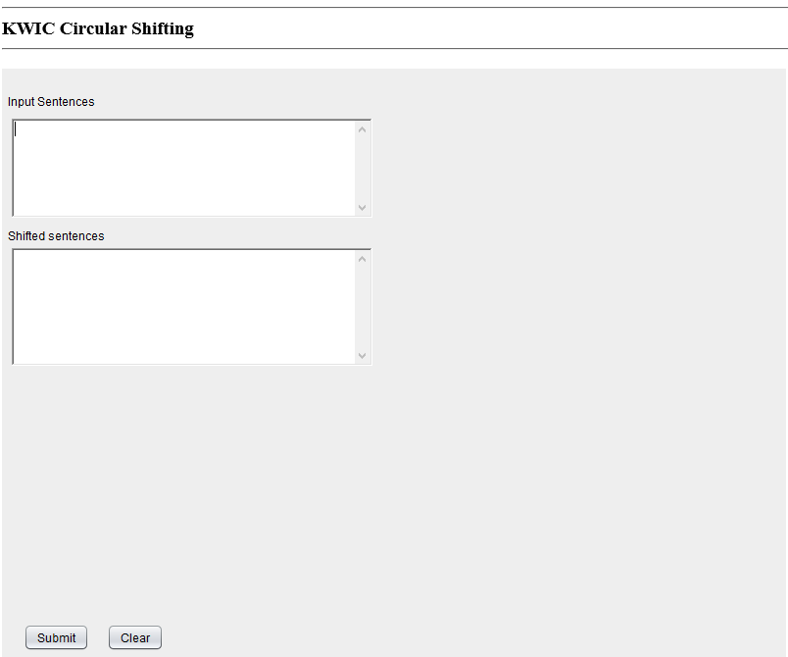

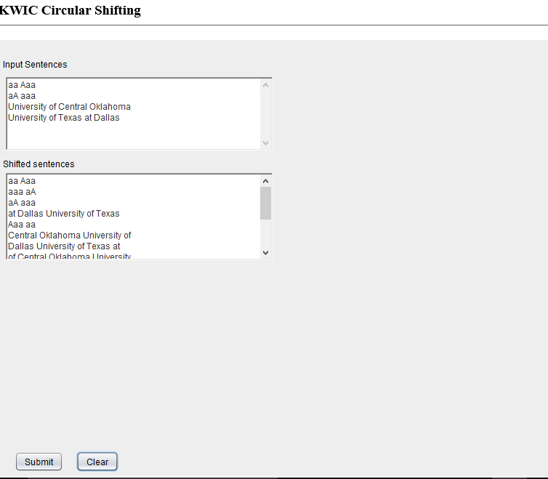

5. Notes

From the discussion from the class today we updated the sorting to follow a<A<b<B<c<C….<z<Z. The application follows the shifting that is given in the reqirements we did not understand what Noah was asking as our sentences take the first word is appended to the end of the sentence and the second word becomes the new start of the sentence. We also updated the UML diagram to show the more compact flow for the system. Since it is a circular application the MainUserInterface starts the processing of the application. We were not able to implement a fully independent pipe system as currently the byte system of the receiving application sets the parameters of the size of the pipe which can cause a buffer loss or buffer overflow problem when the pipe is written to. With additional time a standardized pipe sizing would be used.